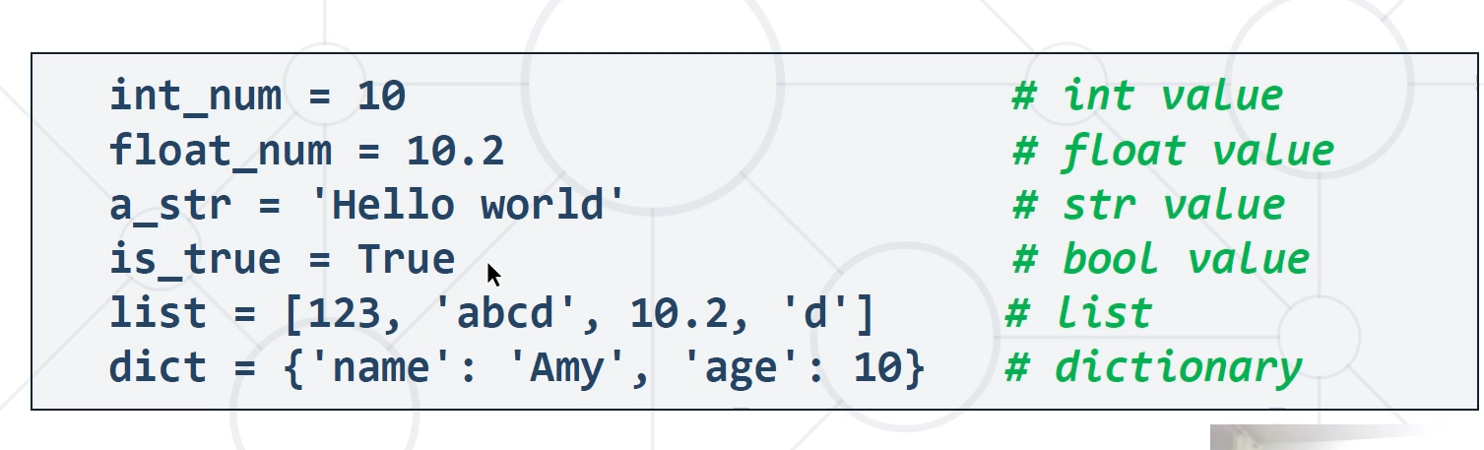

Boolean variables – can hold only True or False
() – run something
[] – list
{} - dictionary

